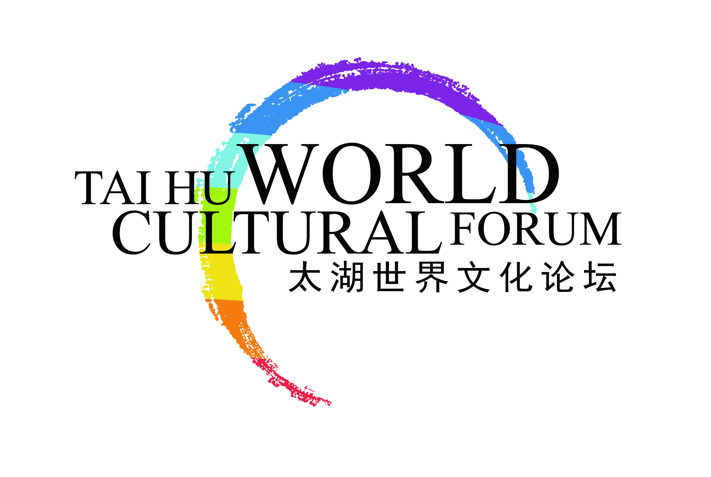

**The Fourth Annual Conference of World Cultural Forum (Taihu, China)**

Executive Summary (draft)

Macao, China

June 7-9, 2016

**Jointly Build a New Civilization of the Community of Common Human Destiny**

**New Global Situation**

At present, mankind is faced with a stern common challenge of global ecological crisis; economic globalization is deepening while in-depth influence of international financial crisis continues and the world economy is amid further restructuring; world multi-polarization continuously advances while the world situation remains intertwined and involved and terrorism and regional conflict continue to happen; societal informatization experiences rapid development while Internet control and global network security have also been listed on global agenda. In the present world, all countries have unprecedentedly deepened interconnection and mutual dependence; the destiny of mankind is highly interdependent; and mankind has more and more become an all-involved community of shared destiny. The forming of the community of common human destiny foretells advent of the stage of new civilization of mankind and this new situation requires us to have a deeper understanding of the following issues concerning the community of shared destiny and future development of mankind:

* Conflict between different forms of civilization still exists. So, in order to build the community of common human destiny, it is necessary to explore the matter of how to raise the greatest common divisor in value between different countries and between different forms of civilization.
* While ecological crises such as climate change threaten the existence of human kind, the awareness of global ecological preservation and ecological awareness of people have been awakened. However, international cooperation in coping with global ecological crisis remains in an impasse.
* Outdated international relations built on a “center-margin” layout of strength and the zero-sum game of protecting one’s own interests at the expense of others between countries have hindered the forming of the community of common human destiny.
* The Silk Road was the historical channel of communication between Oriental and Occidental civilizations. As for the modern “The Belt and Road Initiative” endeavors, the question remains how to inherit the legacy of Silk Road so as to open up a new path for building the community of common human destiny.
* The wide application of information technology in society has brought mankind enormous opportunities for development, but at the same time poses threat and challenges to network security. There is a need for mankind to identify the ways and take effective actions to open up a new era of community of shared wisdom of mankind.
* Globalization may lead to the emergence of underprivileged culture or even cause loss of cultural diversity. Under the context of a new round of globalization, there is a need to explore the ways to build a community of shared creativity of mankind rich in the inherent value of cultural diversity.
* With exponential development of modern medical science, there is a need to answer the question of how to evaluate the theory and practice of traditional medical science so that traditional medical science can become the treasure house of resources for a community of shared health of mankind.
* Given high unemployment rate of youths, there is a need to address the issues of how the youth generation can undertake social responsibilities, and how to address the issues of unbalanced development of women across countries and regions and the unequal distribution of rights, opportunities and resources between men and women.

The Fourth Annual Conference of World Cultural Forum to be held in 2016 will provide leaders with a high-level platform for exploring new global situation as well as the ethos of new civilization of community of common human destiny. The goal of the conference is to develop insight and formulate necessary initiatives and consensus so as to cope with all present and future challenges. Global leaders from governments, international organizations, academic communities, business circles and civil society will engage in a series of dialogues, exploring together issues related to the building of the community of share destiny of mankind. The Fourth Annual Conference will continue to serve as a platform of high-level dialogue for promoting Sino-Foreign cultural exchange and cultural development of the world.

The Fourth Annual Conference will include themed forums, seminars, interactive conferences, round-table conferences, and high-level dialogue, with a focus on exploring the following agenda items:

**Global Agenda**

One thousand Chinese and foreign political dignitaries, renowned scholars, lead entrepreneurs and media figures will be present at the Fourth Annual Conference to explore how to improve global governance and build jointly a new civilization of community of common human destiny. Global agenda items to be explored include: the greatest common divisor in value among different forms of civilization and theory and practice of dialogue between different forms of civilization; concept of ecological preservation and its transformation today among various forms of civilization; addressing the impasse in cooperation to deal with, and the in-depth root cause of, global ecological crisis; moral basis of a new type of international relations and community of common human destiny and the concept of “Consensus with Differences and Win-win Cooperation” inherent in the community of common human destiny, among others.

**Cultural Agenda**

Thanks to UNESCO’s efforts of promotion, the international community has reached consensus on “cultural diversity” as the fundamental nature and rights of mankind, and agreed on the need to develop creative economy as a means to preserving “cultural diversity”. Meanwhile, “cultural diversity” is also regarded as the cornerstone for building community of common human destiny. In this context, participating scholars and guests will engage in discussion under a number of agenda items, including theory and practice of cultural diversity, the role of global creative urban network in promoting new civilization of cities, and the impact of cultural diversity on global localization.

**Regional Agenda**

The Fourth Annual Conference will conduct in-depth discussions on the role of cultural exchange across the world in shaping the new civilization of community of common human destiny. The conference will be focused on the following agenda items: diversified civilization and cultural interaction of countries along “The Belt and Road Initiative”; cultural initiatives (e.g. ecological construction along silk road, transnational cultural industry projects, etc.) to promote the development of “The Belt and Road Initiative”; modern silk road and evolution of traditional East Asian Economic Circle; experience of multiple cultural integration in Macao area; and Chinese culture of increasing common interests and dissolving differences.

**Industry and Business Agenda**

The Fourth Annual Conference is the best platform for social entrepreneurs and various industry leaders to gather and explore matters related to corporate culture and responsibilities in the context of building the community of common human destiny. Along with participating guests, entrepreneurial leaders will discuss agenda items including cultural reflection in the era of economic globalization; corporate culture and responsibilities along silk road and corporate ecological responsibilities; and creation of new mode of global development through “Internet +” initiatives.

**Future Agenda**

The Fourth Annual Conference will gather pioneers in the fields of media, medicine and pharmacology, art and culture so that they can explore together all sorts of ideas, innovation and discoveries that are reshaping the world layout and promoting the forming of community of common human destiny. The agenda items of the annual conference in this context include modern information technology revolution and its impact on global culture, and the role of new media in promoting experience exchange of human civilization; legacy of global traditional medical science and its modern value to the community of shared health of mankind; the role of youths and women as new force for building community of common human destiny, among others.

**The Most Important Global Community of Leaders of Multiple Stakeholders**

World Cultural Forum sincerely invites the following members to be present at this Annual Conference:

-Chinese and foreign political dignitaries

-Heads of international organizations

-Renowned experts of the academic circle

-Social entrepreneurs

-Media leaders

-Distinguished cultural personages

We intend to advocate through the Annual Conference a new concept of civilization that is focused on “Consensus with Differences” and “Win-win Cooperation”. This will promote the building of community of common human destiny and allow international community to share with the international community about the value of Chinese wisdom in coping with modern international relations and global crises. It is also hoped that a platform will be created for initiating dialogues between different forms of civilization in support of the “The Belt and Road Initiative” initiative. This will illustrate China’s new concept in advancing the creation of community of common human destiny to neighboring countries and countries along One Belt and One Road, as well as other countries in the world. The Fourth Annual Conference will call on leaders of all fields in the world to join hands in embracing a more harmonious and prosperous era. To this end, we need to lay solid foundations from all aspects, break away from outdated patterns of thinking and behavior, and facilitate the emergence of new civilization.