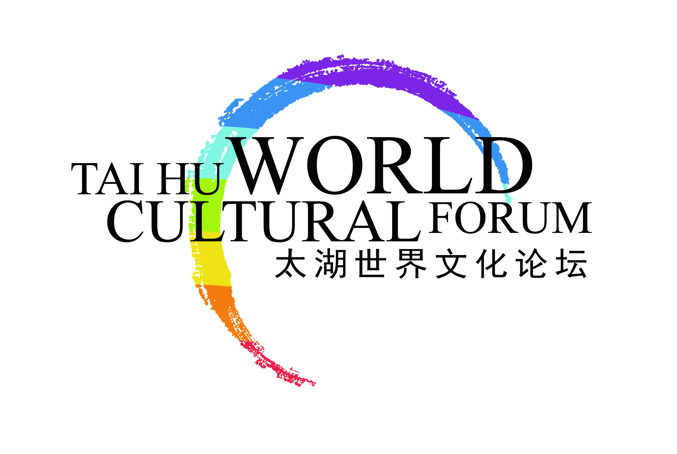

**Introduction of World Cultural Forum (Taihu, China) and**

**Previous Annual Conferences**

**World Cultural Forum (Taihu, China)**

World Cultural Forum (Taihu, China) is a high-level unofficial international cultural forum with strong support from Chinese government. It was founded in March 2008 approved by the Ministry of Civil Affairs of China. Its executive board of directors is located in Beijing. Based in China, this organization embraces the whole world. It is a positive, strong civil power to serve the public diplomacy and cultural diplomacy. To offer an open, inclusive, diversified and high-level dialogue platform for cultural exchanges, it invites people from all over the world to discuss the strategies for dialogue and cooperation between different civilizations.

Chairman of World Cultural Forum (Taihu, China) is Yan Zhaozhu (Chinese famous literary theorist, former director of cultural studies of the CPC Central Policy Research Office). Chinese honorary presidents of the Forum are Zhang Meiying and Sun Jiazheng (Vice-chairperson of the 11th CPPCC of PRC). Foreign honorary Presidents of the Forum are Romano Prodi (former Prime Minister of the Republic of Italy), Jean-Pierre Raffarin (former Prime Minister of the French Republic), Megawati Sukarnoputri (former President of the Republic of Indonesia) and Paul Edgar Philippe Martin (former Prime Minister of Canada).

**The First Annual Conferences of World Cultural Forum**

From May 18th to 19th, 2011, the first annual conference of TCF themed “Dialogue and Cooperation for World Harmony and Common Development” was successfully held in Suzhou. Chinese and foreign guests from 31 countries and regions including Liu Yandong (member of the Political Bureau of the CPC Central Committee), Yusuf Gilani (prime minister of Pakistan), and Megawati Sukarnoputri (former president of Indonesia) attended and addressed the conference. Other attendees included Ervin LASZLO(Founder and President of The Club of Budapest), Robert A. MUNDELL(the recipient of the Nobel Memorial Prize in Economics,“Father of the Euro” ), ZHENG Xinmiao(President of the Palace Museum, Founder), Kyung Hee(Professor of the University of Seoul)etc. They conducted various forms of dialogues and discuss the topics including “Historical Inspirations and Practical Values of Different Civilizations”, “Diversity of Cultures and Progress of Human Civilizations”, “Cultural Perspective of the Global Financial Crisis” etc, advancing the equality among different cultures and facing the global challenges together.

**The Second Annual Conferences of World Cultural Forum**

From May 18th to 19th, 2013, the second annual conference of TCF themed “Enhancing International Cooperation and Establishing Ecological Civilization” was successfully held in Hangzhou, Zhejiang province. Chinese President Xi Jinping met with Armando Emilio Guebuza (president of Mozambique) at the Great Hall. Premier Li Keqiang met with Antonis Samaras (prime minister of Greece) at the East Gate Plaza of the Great Hall before the Conference. Yu Zhengsheng, member of the Politburo Standing Committee and Chairman of the National Committee of the Chinese People’s Political Consultative Conference (CPPCC), delivered a speech at the opening ceremony. Armando Emilio Guebuza (president of Mozambique), Louis Lake Tuck (governor of Anbar), Antonis Samaras (prime minister of Greece), Ruud Lubbers (former prime minister of Holland), Zhang Meiying (vice chairperson of the 11th CPPCC), and Xia Baolong (secretary of Zhejiang Provincial Committee of the CPC) attended the opening ceremony and delivered speeches. Other attendees of the conference included the Director of the United Nations Alliance of Civilizations Matthew Hodes, Director of the Office for Sustainability at Southern New Hampshire University Roy Morrison, American ecologist Michael Tobias, Head of the Chair of Philosophy, Financial University of the Government of the Russian Federation Alexander Chumakov, Academician of American Academy of Science, founding Director of Institute for Advanced Hu monistic Studies at Peking University Wei-ming Tu, Vice President of the Academy of Chinese Culture Ye Xiaowen, etc. About 500 attendees from the world's five continents and 23 countries, including politicians, natural scientists, social scientists and celebrities conducted various forms of dialogues and discuss the ecological civilization construction plans together.

**The Third Annual Conferences of World Cultural Forum**

The third annual conference of TCF themed “Enhancing Interaction of Cultural Soft Power and Promoting World Peace and Development” was successfully held in Shanghai from June 18th to 19th, 2014. Liu Yandong (member of the Political Bureau of the CPC Central Committee), and Han Zheng (Member of the Political Bureau of the CPC Central Committee and Party Secretary of Shanghai) attended and addressed the conference. Chinese and foreign dignitaries, politicians, famous scholars both home and abroad, entrepreneurs, and members of media, up to more than 1,000 people attended the Conference. Other attendees included Nassir Abdulaziz Al-Nasser(the President of the 66th Session of the United Nations General Assembly), Andre Azoulay(The Counselor of His Majesty the King Mohammed VI(Morocco), President of the Euro-Mediterranean Anna Lindh Foundation), Mikhail Efimovich Shvydkoi(Special representative of Russian President for International cultural cooperation), Robert Blackwill(The United States Ambassador to India(2001-2003) and HenryA. Kissinger Senior Fellow for U.S. Foreign Policy at the Council on Foreign Relations), Ernest Wilson(Professor and Dean of the Annenberg School for Communication & Journalism at the University of Southern California), Wang Jisi(President of the Institute of International and Strategic Studies, Peking University), Chao Gejin(President of Institute of Ethnic Literature, Chinese Academy of Social Sciences). They conducted discussions and cooperation regarding to topics such as “Enhancing communication and interaction of cultural soft power, constructing new Sino-US relation”, “Enhancing communication and interaction of cultural soft power, developing friendship between China and foreign countries” and “Deepening innovation and interaction in culture industry, enhancing national cultural soft power”, etc.