Circular Metropolitans in Europe
Case study: Amsterdam
IPP August 2018
By: Mehri Madarshahi
Senior Economist, (Emiratis) United Nations, New York
Introduction
Cities present a sustainability conundrum. While they are engines for economic growth, political power, hubs for innovation and the most efficient means of service distributions, they remain, large-scale consumers of water, energy, natural and processed products, and account for more than 80% of the world’s greenhouse gas emissions,
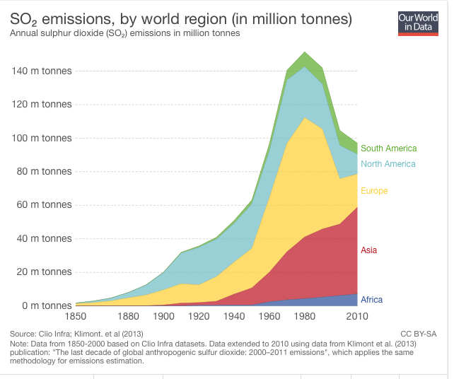
https://www.stateofglobalair.org/data

According to the Food and Agricultural Organization of the United Nations (FAO), the world’s population will grow to nine billion people by 2050, and, as the world urbanizes, the demand on resources rises. This demand, combined with the finite supply of resources, will lead to scarcity and strong price fluctuations.

Population growth since 1900 and its rise in 30 years
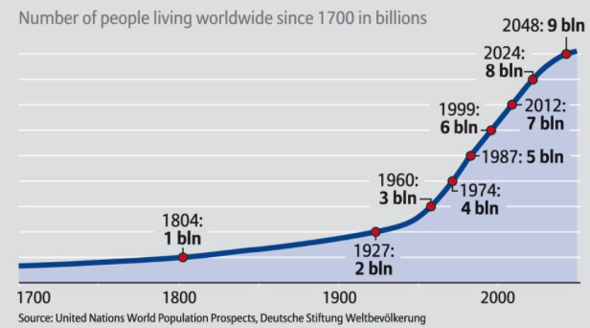
- As cities grow, their increasingly complex infrastructures and services, they undoubtedly become threatened by the consequent spatial changes All metropolitan areas worldwide face the same problem, namely ensuring the quality of urban life, the sustainability and resilience of vital systems, providing energy, water, food, materials, housing, mobility and information, while fostering prosperity and economic growth. The present systems and infrastructures for the provision and management of essential services in cities are the result of several decades of evolution. Nevertheless, the urban centers continue to change both in size and density. Technological advances and new threats of discontinuity such as climate change and resource scarcity have now increasingly created new challenges for the proper functioning of the cities. These problems are complex and call for a shift to a new paradigm and rethinking the present practice of economic models. Our linear way of producing and consuming is under pressure. Cities of today and tomorrow need novel and integrated metropolitan solutions that could focus on the exploitation of possible synergies at a mega scale ensuring a more resilient and integrated sustainable food, energy, water and material nexus
- The new thinking must focus on ‘design for circular reuse’ and integrated generation based on renewable sources, new carriers and services, storage and demand–supply matching through smart infrastructures, and, combined with green– blue urban environments based on integrated water, nutrient and material recovery, sharing services and demand–supply chain optimization..

- The circular economy offers cities a systemic framework to address some of their most pressing challenges and create new opportunities for building resilient and prosperous communities reconciling social, cultural and environmental governance, Reallocation of cars in the urban systems and emphasis on walkability, bike-ability and dedicated low-emission mobility require adopting new thinking by the citizens, Technology and innovation, are critical components in social integrations, empowerment of the citizens and driving economic growth in the metropolitan circles.
`Integration of circular economy in metropolitan circle
- 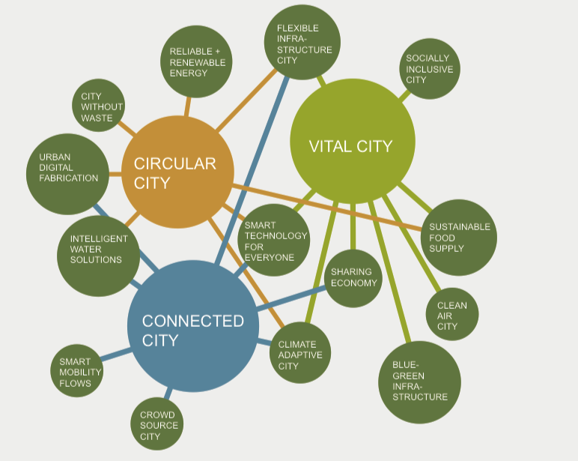

- In this presentation, the existing urban infrastructure and environments are redesigned to integrate not only consumption by, but also production for citizens in the context of i.e. circular city, In such a scheme the redesign of urban green and blue morphologies and urban infrastructures must increase resilience to disruptive changes (both climate and economy related) and meet the health and biodiversity needs of metropolitan areas.
- Circular cities of the future are fully adapted to the consequences of climate change They aim to eliminate the concept of waste, keep assets at their highest utility at all times, and are enabled by digital technology. They produce and promote use of renewable energy, adaptable infrastructure to the need of the city and to its citizen and fully planned mobility to move from points A to B A. Metropolitan circles embed the principles of circular economy across all their functions, establishing an urban system that is regenerative and restorative by design
- The impact on how cities are conceived, materialized and operationalized in a circular framework can hardly be overstated. Owing to complexity of cities some impacts can be imagined and others -at best have to be anticipated. The implications of a circular agenda are thus significant, and we only just begin to fathom its magnitude.

- In addition, the proliferation of various interpretations of the meaning of circularity and its new value systems by the cities and citizens also has created difficulties for the urban planners. Some interpretations are essentially linear processes to be made more efficient: example is that are among some European models and that of the Greater Bay Area project in China. Whereas other interpretations may seem ‘too holistic ’ such as the proposed plan for Amsterdam where not only the formation of the cities will change from linear to circular but also the whole value systems of the citizens as well as their economic practices will be revamped.

Linear Versus Circular models in city plannings
The most prevailing practices in city planning maintaining linear approach with modifications are those examples to be found among a number of European cities such as Great Britain, Spain and Italy. These cities aim at using innovative crowd management, better use of bike and pedestrian spaces, more robust and resilient public transport and more efficient use of low emission cars and other modalities such as water, energy, waste, data and food. Many try to eliminate the concept of waste, keep assets at their highest utility at all times, and are enabled by digital technology.
A coupe of example may highlight some of the on-going efforts. While many cities share rides, London has taken the sharing model one step further, introducing a “Library of Things”, where people actually share electronics and appliances. A genius concept extending the useful life of many assets and vastly reducing the quantity of new products purchased and eventually discarded.
Italy is focusing its circular efforts on waste management, piloting door-to-door collection and citywide second-hand markets in Cremona. The city has also introduced a tariff on any waste that cannot be collected. In just two years, Cremona has increased recycled waste from 53% to 72%.
This initiative as part of a larger roadmap explicitly connects with and builds on the many plans that are already being or will be implemented.
On the other hand, Paris is a good example of a circular city in European context
Originally its series of little villages came together and created its circular structure with 20 arrondissements today

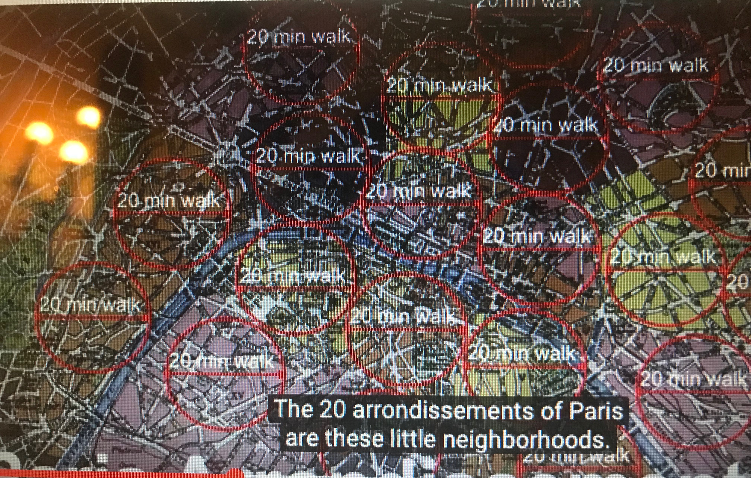
- The French MAPTAM law (Modernization of Territorial Policy and the Cities) of January 27, 2014 created the Greater Paris Metropolis (GPM). The latter is organized into regional government agencies (EPTs) and will unite Paris with the municipalities of the inner suburbs (Hauts-de-Seine, Seine-Saint-Denis and Val-de- Marne départements), i.e. 124 municipalities
- The GPM will thus have a population of nearly 7 million, or more than half of the region’s inhabitants, and will exercise four major authorities: metropolitan area planning, local housing policy, economic, social and cultural development and planning, and air and environmental protection. The Metropolis will also be responsible for harmonizing electricity, gas, heating and cooling distribution networks

- The French Agency for the Environment and Energy Management (ADEME) defined the circular economy according to seven pillars in order to uncouple economic growth and the consumption of natural resources: Sustainable supply, eco-design, Industrial and Regional Ecology (IRE), Product-Service System, sustainable consumption, extending the duration of use (re-use, repair, and re-utilization), and recycling.
- Francois Mauriac said: "What does it serve man to win the Moon if he loses the Earth." Let us make the planet’s protection a political priority!
- The digitization of public and private life is eminent and the Internet of thing will enable the city planners to create a connected city and more intelligent urban infrastructure at scales that were previously unthinkable.

In China the new tendency is to create a new interconnected transregional transportation networks as a strategic corridors for accelerating smart development and safeguarding institutional innovations. It also aims at bridging the gap between urban and rural development and facilitate rural development. Under this scheme, the distribution of
industrial projects in these cities and in county towns will be guided and , improve ments municipal infrastructure
and public service facilities, will be underlined

forming metropolitan circles. are being ‘crowd sourced’ for novel information and knowledge. The do-it-yourself movement, facilitated by social media and the web, gets people involved

- Amsterdam wants to be the front-runner in circularity, and the Amsterdam region is in a good starting position for transitioning to a circular economy. The region has many entrepreneurial and innovative businesses, citizens, start-ups, organisations and knowledge institutions that are already working within the framework of a circular economyThe economic activity of the Amsterdam metropolitan region amounts to 106 billion euro annually, of which 47 billion is accounted for by the city of Amsterdam (2013) (CBS, 2015).
- The following sections summarise the future vision and roadmap that have been developed for both chains and the impact that the implementation of these would have on the economy and the use of materials.
- Amsterdam focus is on five interconnected pathways: low emission development, resilient development, nature based development, equitable and people-centered development as well as circular development.. It uses circular economy representing a new model for economic development based on redesign, reuse, repair, remanufacture, recycle and restore resulting in high resource use efficiency where it seeks systematically increasing environmental capacity and reduce its ecological footprint, Amsterdam plans to coordinate ecology, and human life systematically by improving/redesigning its urban transportation, community development, and the integration of the built environment with smart concepts for the connection of mobility, energy generation, storage and exchange. Through its various experimentations Amsterdam has identified that redesigning product and material supply chains can save the city 85 million euros per year in construction costs and 150 million euros per year through use of organic residual streams. The economic activity of the Amsterdam metropolitan region amounts to 106 billion euro annually, of which 47 billion is accounted for by the city of Amsterdam (2013) (CBS, 2015).
- The following sections summarise the future vision and roadmap that have been developed for both chains and the impact that the implementation of these would have on the economy and the use of materials.
- Smart design of buildings is important in the transition to a regional construction circular chain. One of the aspects of smart design is a modular and flexible approach, whereby buildings can be updated to new users and other applications without sacrificing the current safety guidelines. 3D-printing New technologies, such as 3D

The design for a circular metropolitan in Amsterdam entails moving towards radial sectors and belts via pathways into areas known as circulars or rings. Circular belts then subdivide the radial Sectors
Which extend outward from a central point forming a
Widening circular grid structures. As the circle widens more circular belts follow until the perimeter is reached where in the environment is allowed to return to
Wild nature without any form of sprawl.

Total City system

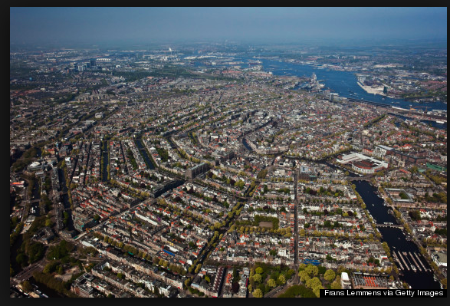

source: Frans Lemmens via Getty images

- Amsterdam concluded that:
- Circular scheme is more efficient than other city layouts
- In such design, all facilities such as mass transit, medical and other common needs could be located near the center
- Starting at one point on a circle can eventually bring one back to the same point ensuring travelling in the city relatively easy. In a linear city one has to travel back again to get to the same point
- Planned circular design minimizes the length of all transportation and distribution lines
In such a circular City one will be within a reasonable distance to access every facility the city has to offer. The proposed circular shaped City ensures that no access point on the circle is ever further away than half the circumference of the circle itself that is an important design consideration for emergency.

In such design, resources that drive human activities are by definition regenerative rather than linear or degenerative: be it energy, water, materials, nutrients or clean air. Therefore, the focus shifts from gradual destruction of resource-value - “take, make, waste” – to value-creation through models based on cascades and cycles.

Deconstructions and reuse

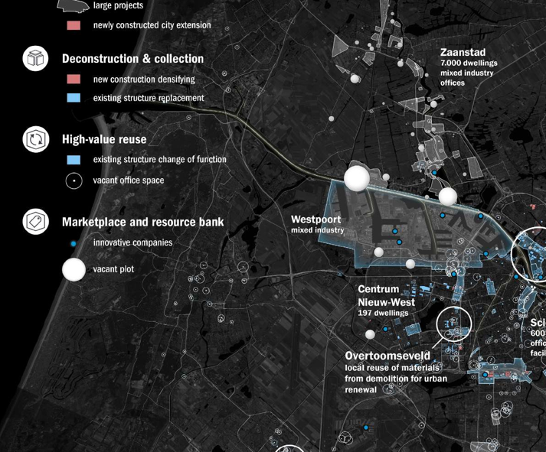

source: Amsterdam.nl

Research programs are essential part of such planning. Their focus is on three, strongly interrelated subthemes: materials & buildings, nutrients recovery, and urban energy systems. Each subtheme has its own research priorities, informed by the interplay between city, society and science, and rooted in the definition that circular cities are cities that understand, establish, monitor and control circular economy principles in an urban context, whilst realizing the vision of a resilient, future-proof city.

- An important focus within the theme of materials & buildings is on materials temporarily stored in built constructions for diverging periods of time. Including the question how to streamline supply, demand and conversion processes of those materials, components and buildings. The 2nd theme concerns nutrient recovery from (waste) water streams. At stake are methods and systems to better reutilize nutrients, materials and energy in water flows, as well as the integration of wastewater treatment systems on different scales in urban regions. The 3rd theme centers on the transition to renewable energy sources and its infrastructural implications, dealing with increased variability in consumption, storage and production at multiple scales. This theme accentuates innovation in systems engineering & integration, energy storage, and information technology, adopting a citizen perspective. Greenhouse gas emissions are estimated to decrease by half a million tonnes of CO2 per year
- equivalent to 2.5% of the current annual CO2- emissions of the city of Amsterdam
- This future circular scenario is based on a variety of adopted measures, including source separation of organic waste in all 430 thousand households in Amsterdam. Separate collection makes it possible to direct the organic waste stream to new uses, such as the production of protein for animal feed, biogas and building blocks for the chemical sector, including the production of bio- plastics. In addition, organic waste streams from the food processing industry
- this scenario is estimated to create an additional 1200 jobs in Amsterdam, on top of the current total of 10 thousand jobs in the agriculture and food processing industry. Some of the jobs created will arise from the required adjustments to the waste infrastructure, including the installation of underground containers, pick up services for the separate waste streams and the more complex processing of waste flows.

Adaptive circular cities



source: urbantransfor.eu
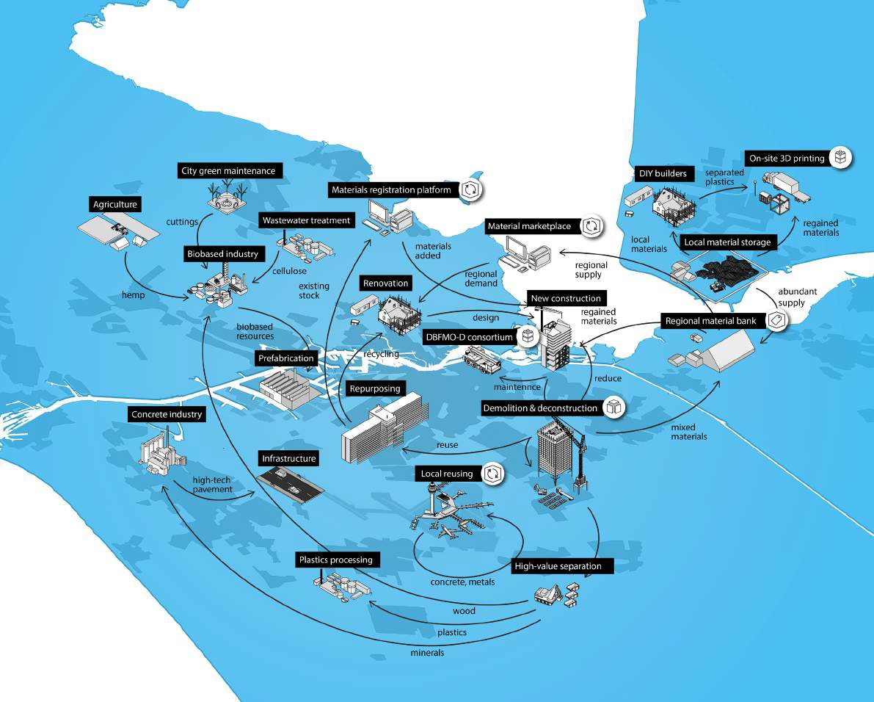
Vision of a Circular Construction Chain (smart demolitions, identifying reuseables)

Source: circular.economy.com

The impact on how cities are conceived, materialized and operationalized in a circular framework can hardly be overstated. Owing to complexity of cities some impacts can be imagined and others -at best have to be anticipated. The implications of a circular agenda are thus significant, and we only just begin to fathom its magnitude.
- Circular design means less to build and less to maintain and hence more efficient
- Use of space, circule provides the most efficient form of infrastructural elements
- Replicating the same access points and designs means fewer resources than conventional construction methods
- extremely cost efficient since it requires one central radial to be designed and then replicated throughout the radials
- A city with square blocks can expand indefinately

In addition, the proliferation of various interpretations of the meaning of circularity and its new value systems by the cities and citizens also has created difficulties for the urban planners. Some interpretations are essentially linear processes to be made more efficient: example is that of Italy. Whereas other interpretations may seem ‘too holistic ’ such as the proposed plan for Amsterdam where not only the formation of the cities will change from linear to circular but also the whole value systems of the citizens as well as their economic practices will be revamped.

Nevertheless, the present urban environment around the globe is in dire need of a different approach. Resource depletion and waste generation are two phenomena that, due to their non-regenerative and polluting character, hinder healthy and sustainable development of urban environments. The transition to renewable energy sources requires smarter energy infrastructures that are able to deal with increased variability in consumption, storage and production at multiple scales. Reliable and sustainable energy systems for the urban environment can have also the potential to reduce CO2 emissions and improve urban quality of life. A shift from linear to circular resource management could, therefore, offer a potential solution for the present models of metropolitan operations and planning.

Total City System in Metropolitan circles

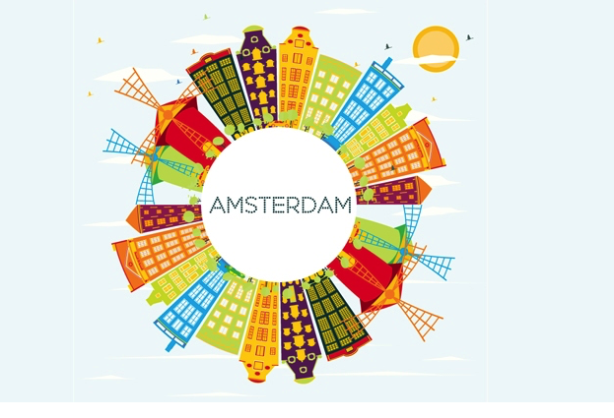
source: edic.net

It is important to review systematically design processes to address the behavior and accessibility of systems and objects over time as well as to assess whether digital mechanisms for city infrastructure such as waste management, water, sanitation and power supply can be better designed for future platforms.
Urban design and architecture must also follow trends of new visions and lifestyles. Planners must reserve space for future development such as infrastructure and public facilities and so on
New technologies and research findings can assist to make an urban center more livable and beautiful. In order to link cultural policy with industrial policy, urban planning, and environmental policy, the vertical administrative structure must be made horizontal, ordinary bureaucratic thinking must be eliminated, and organizational culture must be changed

A long road ahead but the difficulties are not insurmountable.

References:

AMS- Report. Amsterdam Institute for advance metropolitan solutions (The City of Amsterdam commissioned this report on the potential circular economy in Amsterdam and the Amsterdam Metropolitan Area).

The Guide to the Circular Economy: Capturing Value and Managing Material Risk
Dustin BentonJonny HazellJulie HillSeptember 8, 2017
Routledge

Designing for the Circular Economy
Martin CharterAugust 6, 2018
Routledge

Source Separation and Recycling

The Handbook of Environmental Chemistry
Book 63
Roman MaletzChristina DornackLou ZiyangMarch 7, 2018
Springer

- Le Monde (2015), Économie circulaire, ces entreprises qui ouvrent la voie (Circular Economy

European Commission” "The Roadmap to a Resource Efficient Europe,” setting the major strategies to be implemented by 2050;

Development of Circular Economy in China
Jianguo QiJingxing ZhaoWenjun LiXushu PengBin WuHong WangOctober 12, 2016
Springer ISBN
9789811024665

GemeenteAmsterdam 16 Dec 2013

Towards the Amsterdam Circular Economy
Conservation and Recycling; Vandermeersch, et al. (2012) ‘Environmental sustainability assessment or food waste valorisation options’

Circular Amsterdam: A vision and action agenda for the city and metropolitan area.-City Circle Scan report (phase 1)

White paper on the Circular economy of Greater Paris- Initiative of the City of Paris, 2018 (representing the first step for greaterParis to move twards cirdular economy)

CIRCULAR
AMSTERDAM

A vision and action agenda for the city and metropolitan area

