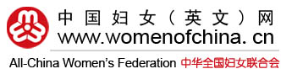
January 30, 2017November 30, 2016
Sign in Register
Newsletter Subscription
Give Your Comments
Search..
Content
Editors' name
Authors

FOLLOW US:

- Home
- News
- People
- Features
- Exclusives
- Opinion
- Culture
- Survey
- Publications
- Projects
- Photos
- Sources
- Special Coverage
- ACWF
{section:20584}
Features / Spotlight
{listing:23703}
Nishan Women's Forum Focuses on Gender Equality and Female Empowerment
November 22, 2016
Comments(1)
Share

<script type="text/javascript" charset="utf-8" src="http://static.bshare.cn/b/buttonLite.js#style=-1&amp;uuid=2ddd3036-1080-4a31-a715-a180bd963380&amp;pophcol=1&amp;lang=zh"></script><script type="text/javascript" charset="utf-8" src="http://static.bshare.cn/b/bshareC0.js"></script>
By Qilu WebEditor: Rong Chen
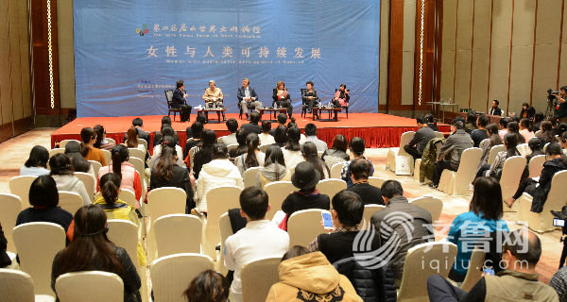
Attendees listen to scholars' dialogues at the Nishan Women's Forum focusing on women and sustainable development. [iqilu.com]

Six global scholars attached great importance to the issue of women's efforts in sustainable development of all mankind during the Nishan Women's Forum on November 16.
For the first time, this women's forum was held in the city of Qufu, east China's Shandong Province, which is known as the birthplace of Chinese ancient philosopher Confucius (551 BC – 479 BC).
Under the theme of "Traditional Culture and Ecological Progress: Marching toward a Green and Simple Life," the forum was affiliated to the Nishan Forum on World Civilizations, which was initiated by Xu Jialu, former vice-director of the Executive Committee of the National People's Congress.
The First Nishan Forum was held in September 2010, during which the Nishan Declaration of Harmony was issued, calling for dialogue and communication among civilizations.
Xu vowed to continue organizing the Nishan Women's Forum whilst focusing on women's progress.
"Women's development has become a global issue highlighted through respecting and taking care of them," believed Xu.
"Children are encouraged to have the consciousness of gender equality, thus eradicating the roots of gender discrimination or violence in later life," suggested Xu.
"The sub-forum was set to make women's voices better heard and to stimulate attention around women's rights protection worldwide," said Liu Chuansheng, principal of Beijing Normal University and vice-chairperson of the organizing committee.
"Global women have contributed to overall global development," pointed out Hans d'Orville, assistant director-general of UNESCO. "To promote gender equality, women should have endowed equal rights with men, for example, in terms of education and employment."
"Even though women have largely promoted global trade, they are less able to have decisive power in key issues compared to men," pointed out Mehri Madarshahi, president of the Melody for Dialogue among Civilizations Association. "Meanwhile, women are encouraged to contribute their efforts from various fields to advancing humans' sustainable development," she added.
"Only 29 percent of Indian women are able to have a job vocation, compared to those who live in remote areas having no consciousness of education, let alone work," reported another Indian scholar.
"The United Nations (UN) has aimed to transform the world we live in after issuing The 2030 Agenda for Sustainable Development, in which gender quality is highlighted as a significant issue among the 17 sustainable goals for the next 15 years," noted Lü Hailin, executive committee president of the UN's Women's International Forum.
"It is important to make groundbreaking and solid efforts in advancing women's development worldwide," noted Zhang Youyun, the forum host and director of the International Labor Organization.
"This forum has shed light upon women's responsibility in global sustainable development, which echoes with the statement of the Nishan Forum in promoting cultural diversification," commented Zhang Yinjun, executive president of the forum.

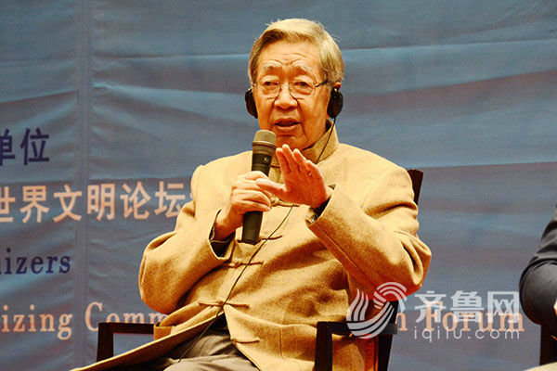
Xu Jialu speaks at the forum. [iqilu.com]

Mehri Madarshahi speaks at the forum. [iqilu.com]

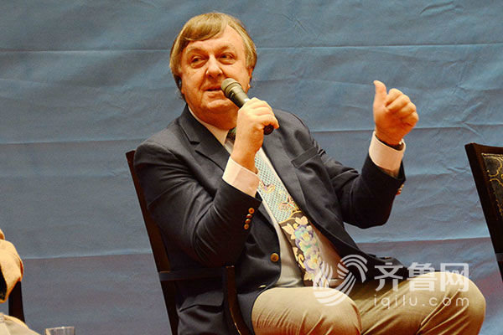
Hans d'Orville speaks at the forum. [iqilu.com]

(Source: iqilu.com/Translated and edited by Women of China)
Please understand that womenofchina.cn,a non-profit, information-communication website, cannot reach every writer before using articles and images. For copyright issues, please contact us by emailing: website@womenofchina.cn. The articles published and opinions expressed on this website represent the opinions of writers and are not necessarily shared by womenofchina.cn.

32.3K
Related stories
Shaanxi Hosts Expo, Women's Forum on Crafts Made Famous Along 'Silk Road'2016-11-11
Female Role-models Share Experiences at Motivational Women's Forum2016-11-09
2016 Global Gender Gap: World Economic Forum Report2016-10-30
ACWF Launches Forum on Women's Poverty Alleviation2016-10-25
Premier Li Keqiang Stresses Gender Equality and Children's Rights2016-11-19
Comments
1
<div class="hn">Comment theme:<a href="/html/report/16114785-1.htm" target="top">Nishan Women's Forum Focuses on Gender Equality and Female Empowerment</a></div>

<tr><td id="Loca">Location：</td> <td><input type="text" name="address" value=""></td></tr>
Name： |  | Nationality： | <script>mt.country('country',null,"Nationality");</script>

Verification code: <a href="###" style="cursor:pointer" onClick="reloadVcode1();">&nbsp;&nbsp;If the code is not clear, please click here for a new code.</a>&nbsp;&nbsp;Messages that harass,abuse or threaten others;have obscene or otherwise objectionable content;have commercial or advertising content or links may be removed. Acquire a new identifying code &nbsp;(Note: Please put in the calculation results)
<tr> <td colspan="2" class="submit"><input type="submit" value="Submit"></td> </tr>
No comment

<div class="hn">Comment theme:<a href="/html/report/16114785-1.htm" target="top">Nishan Women's Forum Focuses on Gender Equality and Female Empowerment</a></div>

<tr><td id="Loca">Location：</td> <td><input type="text" name="address" value=""></td></tr>
Name： |  | Nationality： | <script>mt.country('country',null,"Nationality");</script>

Verification code: <a href="###" style="cursor:pointer" onClick="reloadVcode1();">&nbsp;&nbsp;If the code is not clear, please click here for a new code.</a>&nbsp;&nbsp;Messages that harass,abuse or threaten others;have obscene or otherwise objectionable content;have commercial or advertising content or links may be removed. Acquire a new identifying code &nbsp;(Note: Please put in the calculation results)
<tr> <td colspan="2" class="submit"><input type="submit" value="Submit"></td> </tr>
No comment

{listing:23704}

Related Story
a href=''>More</a
Shaanxi Hosts Expo, Women's Forum on Crafts Made Famous Along 'Silk Road'
Female Role-models Share Experiences at Motivational Women's Forum
2016 Global Gender Gap: World Economic Forum Report
ACWF Launches Forum on Women's Poverty Alleviation
Premier Li Keqiang Stresses Gender Equality and Children's Rights

script> var nullnone=document.getElementById('nullnone'); var RelatedStory=document.getElementById('RelatedStory').getElementsByTagName('span')[0]; if(RelatedStory.innerHTML=''){ nullnone.style.display='none' }else{ nullnone.style.display='block' } </script {section:20560}

Newsletter  Gender: | Male Female
Country:
E-mail:
Gender: | Male Female
Country:
E-mail:

{section:20816}

Online Dictionary

{listing:23700}

Magazines
More
- 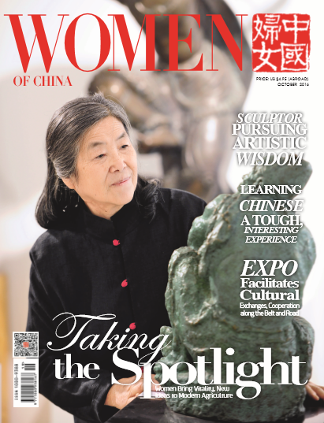
- October Issue, 2016
- {listing:23701}
- 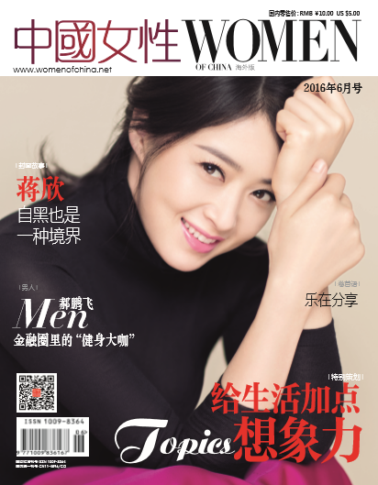
- June Issue 2016

{section:20598}{section:20293}

About Us | Contact Us | Site Map | Advertising with Us | Job Opportunities | Links | Copyright & Disclaimer 京ICP备10020604号
Copyright 2005-2014 All rights reserved. Women's Foreign Language Publications of China. Email: website@womenofchina.cn
{section:20197}

